30.69: a) At 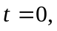all the current passes through the resistor 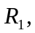so the voltage 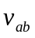is the total voltage of 60.0 V.

b) Point a is at a higher potential than point c) 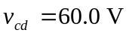since there is no current through 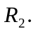
d) Point is at a higher potential than point
e) After a long time, the switch is opened, and the inductor initially maintains the current of 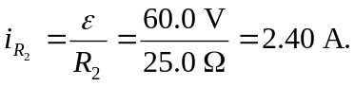 Therefore the potential between and is
f) Point is at a higher potential than point a.
g)
h) Point is at a higher potential than point c.

